**Internet Radio using MAX98357A**

the following is a guide on how to create an internet radio using the MAX98357A amplifier.  
for this tutorial, we used the Arduino IDE.  
**assumptions:**

* you have downloaded the Arduino IDE.
* you have configured the IDE to work with the “DOIT ESP32 DIVKIT V1” board.

a guide to all the steps above can be found in the “bank of knowledge”.

**needed material:**

* ESP32 microcontroller
* MAX98357A amplifier
* breadboard
* WiFi connection
* 6 wires
* a speaker that works with a 3[WATT]/4Ω

**step 1:** download the following Github repository as a zip file to your computer:  
<https://github.com/schreibfaul1/ESP32-audioI2S>  
  
**step 2:** go to the Arduino IDE -> Sketch -> include library -> add .ZIP library -> choose the file you’ve downloaded in step 1.

**step 3:** setup the wiring as shown in the “audio input and output for microcontrollers” presentation, or as follows:

|  |  |
| --- | --- |
| **MAX98357A** | **ESP32** |
| Vin (2.5V-5.5V) | Vcc (preferably 3.3V but can be 5V) |
| GND | GND |
| BCK or BCLK | Pin 27 (G27) |
| DIN | Pin 25 (G25) |
| LRC | Pin 26 (G26) |
| GAIN | GND |
| SD | - |

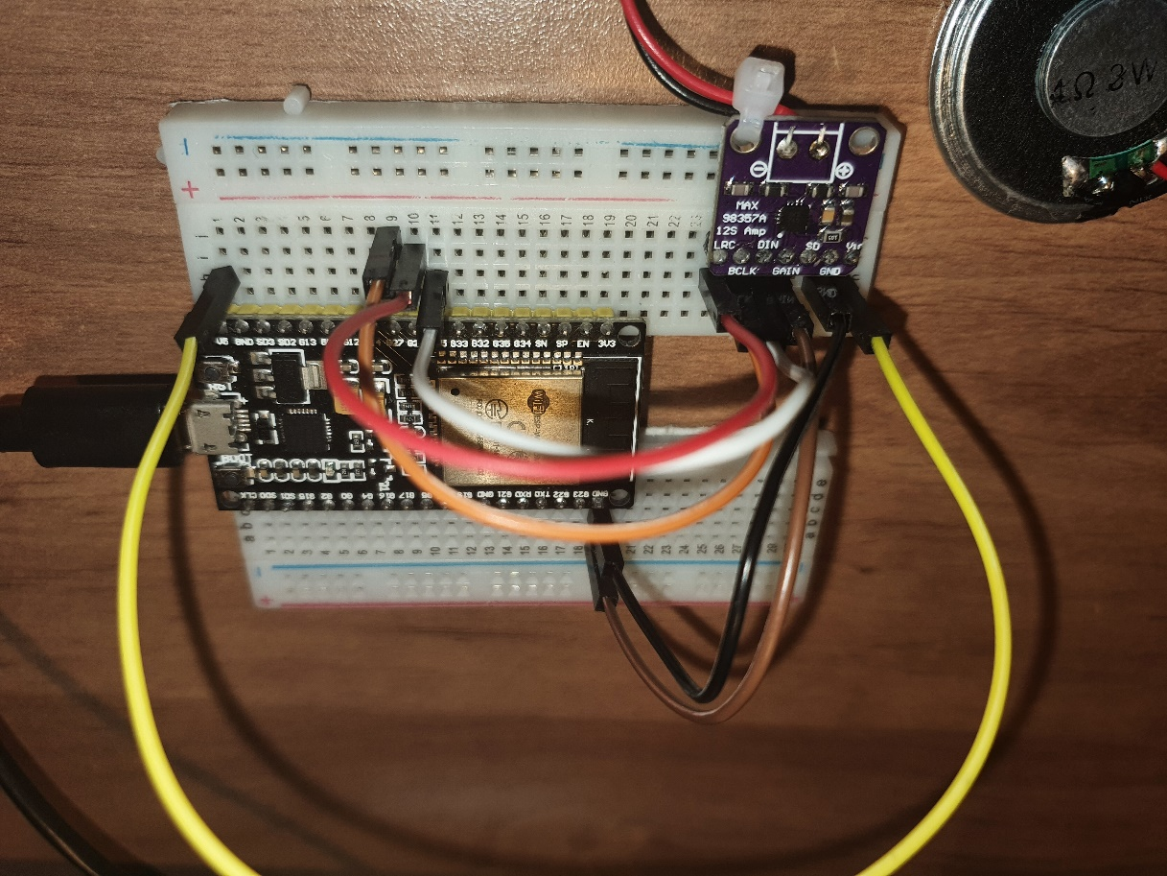

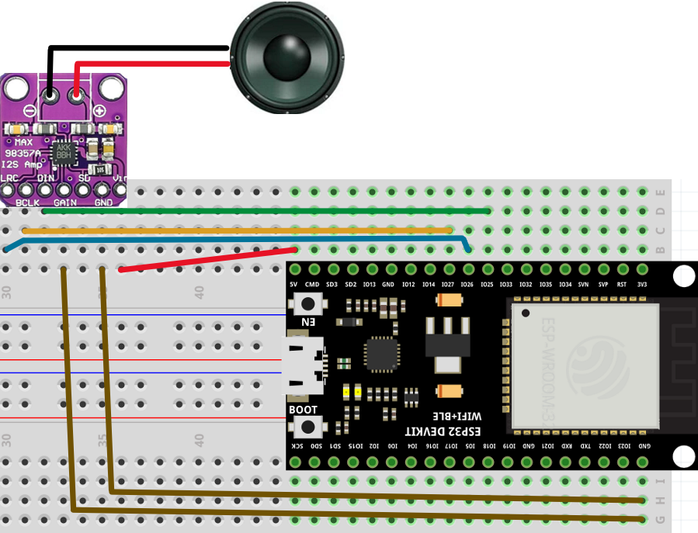

**step 4:** copy and paste the following code:

* #include "Arduino.h"  
  #include "WiFi.h"  
  #include "Audio.h"  
    
  // Digital I/O used  
  #define I2S_DOUT 25 // DIN connection  
  #define I2S_BCLK 27 // Bit clock  
  #define I2S_LRC 26 // Left Right Clock  
    
  Audio audio;  
    
  String ssid = "your WiFi name"; // insert your WiFi name here  
  String password = "your Password"; // insert your WiFi password here  
    
  void setup() {  
   Serial.begin(115200);  
   WiFi.disconnect();  
   WiFi.mode(WIFI_STA);  
   WiFi.begin(ssid.c_str(), password.c_str());  
   while (WiFi.status() != WL_CONNECTED) delay(1500);  
   audio.setPinout(I2S_BCLK, I2S_LRC, I2S_DOUT);  
   audio.setVolume(15); // 0...21  
    
  // audio.connecttohost("http://www.wdr.de/wdrlive/media/einslive.m3u");  
  // audio.connecttohost("http://macslons-irish-pub-radio.com/media.asx");  
  // audio.connecttohost("http://mp3.ffh.de/radioffh/hqlivestream.aac"); // 128k aac  
  // audio.connecttohost("http://mp3.ffh.de/radioffh/hqlivestream.mp3"); // 128k mp3  
   audio.connecttohost("http://vis.media-ice.musicradio.com/CapitalMP3"); // 128k mp3  
  // audio.connecttospeech("Wenn die Hunde schlafen, kann der Wolf gut Schafe stehlen.", "de");  
  // audio.connecttohost("http://media.ndr.de/download/podcasts/podcast4161/AU-20190404-0844-1700.mp3"); // podcast  
  }  
    
  void loop()  
  {  
   audio.loop();  
  }  
    
  // optional  
  void audio_info(const char *info){  
   Serial.print("info "); Serial.println(info);  
  }  
  void audio_id3data(const char *info){ //id3 metadata  
   Serial.print("id3data ");Serial.println(info);  
  }  
  void audio_eof_mp3(const char *info){ //end of file  
   Serial.print("eof_mp3 ");Serial.println(info);  
  }  
  void audio_showstation(const char *info){  
   Serial.print("station ");Serial.println(info);  
  }  
  void audio_showstreaminfo(const char *info){  
   Serial.print("streaminfo ");Serial.println(info);  
  }  
  void audio_showstreamtitle(const char *info){  
   Serial.print("streamtitle ");Serial.println(info);  
  }  
  void audio_bitrate(const char *info){  
   Serial.print("bitrate ");Serial.println(info);  
  }  
  void audio_commercial(const char *info){ //duration in sec  
   Serial.print("commercial ");Serial.println(info);  
  }  
  void audio_icyurl(const char *info){ //homepage  
   Serial.print("icyurl ");Serial.println(info);  
  }  
  void audio_lasthost(const char *info){ //stream URL played  
   Serial.print("lasthost ");Serial.println(info);  
  }  
  void audio_eof_speech(const char *info){  
   Serial.print("eof_speech ");Serial.println(info);  
  }

**NOTE:** make sure that the defined Pins match the wiring!

**step 5:** connect the ESP32 to your computer, compile and run the code. you might need to press on the “reset” button on your ESP32.  
you should see something similar to this on your serial monitor:  
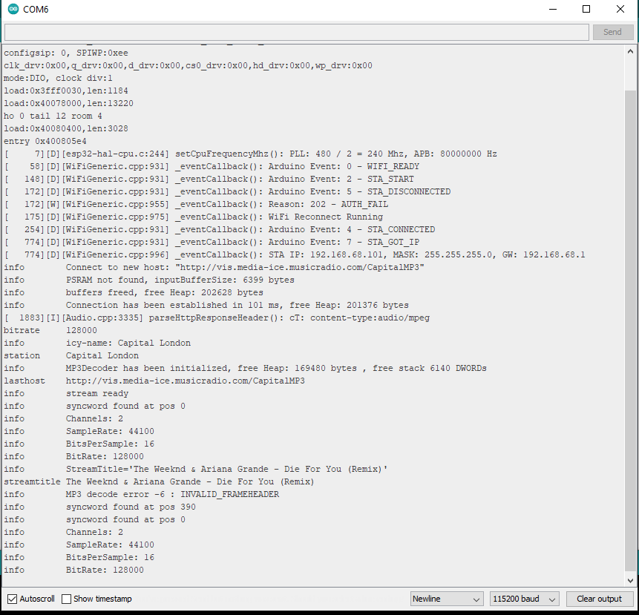  
**step 6:** enjoy your internet radio 😊